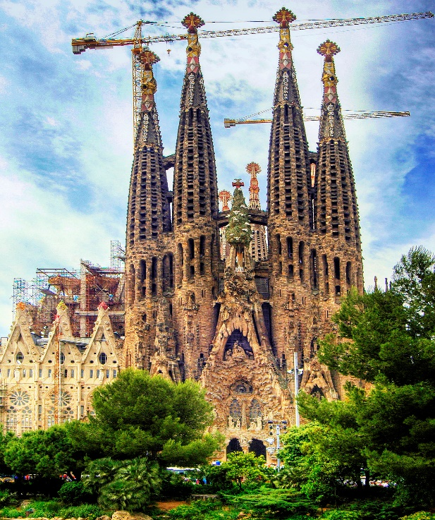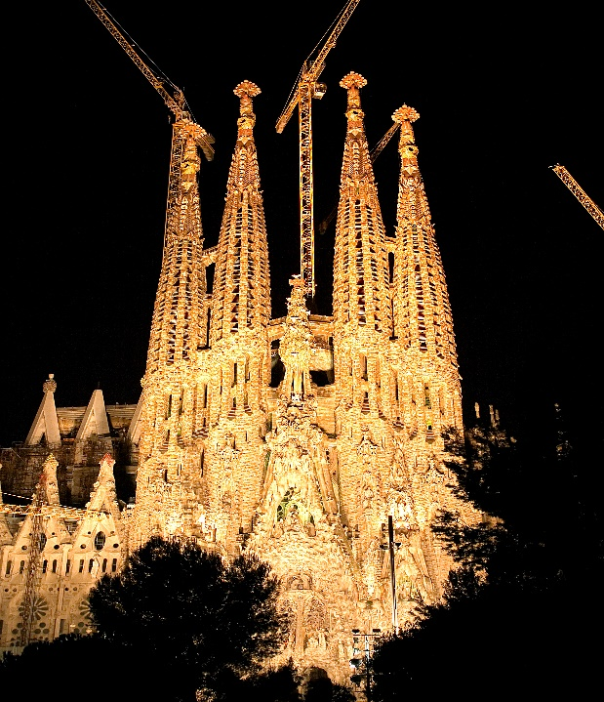

# Sagrada Família

The **Basílica i Temple Expiatori de la Sagrada Família**,[[a]](https://en.wikipedia.org/wiki/Sagrada_Fam%C3%ADlia#cite_note-5) otherwise known as **Sagrada Família**, is a church under construction in the [Eixample](https://en.wikipedia.org/wiki/Eixample" \o "Eixample) district of [Barcelona](https://en.wikipedia.org/wiki/Barcelona), [Catalonia](https://en.wikipedia.org/wiki/Catalonia), [Spain](https://en.wikipedia.org/wiki/Spain). It is the largest unfinished Catholic church in the world. Designed by [Catalan](https://en.wikipedia.org/wiki/Catalans) architect [Antoni Gaudí](https://en.wikipedia.org/wiki/Antoni_Gaud%C3%AD) (1852–1926), in 2005 his work on Sagrada Família was added to an existing (1984) [UNESCO](https://en.wikipedia.org/wiki/UNESCO) [World Heritage Site](https://en.wikipedia.org/wiki/World_Heritage_Site), "Works of Antoni Gaudí".[[5]](https://en.wikipedia.org/wiki/Sagrada_Fam%C3%ADlia#cite_note-UNESCO-6) On 7 November 2010, [Pope Benedict XVI](https://en.wikipedia.org/wiki/Pope_Benedict_XVI) consecrated the church and proclaimed it a [minor basilica](https://en.wikipedia.org/wiki/Minor_basilica).[[6]](https://en.wikipedia.org/wiki/Sagrada_Fam%C3%ADlia#cite_note-7)[[7]](https://en.wikipedia.org/wiki/Sagrada_Fam%C3%ADlia#cite_note-8)[[8]](https://en.wikipedia.org/wiki/Sagrada_Fam%C3%ADlia#cite_note-CNSvisit-9)

On 19 March 1882, construction of Sagrada Família began under architect [Francisco de Paula del Villar](https://en.wikipedia.org/wiki/Francisco_de_Paula_del_Villar_y_Lozano). In 1883, when Villar resigned,[[5]](https://en.wikipedia.org/wiki/Sagrada_Fam%C3%ADlia" \l "cite_note-UNESCO-6) Gaudí took over as chief architect, transforming the project with his architectural and engineering style, combining [Gothic](https://en.wikipedia.org/wiki/Gothic_architecture) and curvilinear [Art Nouveau](https://en.wikipedia.org/wiki/Art_Nouveau) forms. Gaudí devoted the remainder of his life to the project, and he is buried in the church's crypt. At the time of his death in 1926, less than a quarter of the project was complete.[[9]](https://en.wikipedia.org/wiki/Sagrada_Fam%C3%ADlia#cite_note-nyt1-10)

Relying solely on private donations, Sagrada Família's construction progressed slowly and was interrupted by the [Spanish Civil War](https://en.wikipedia.org/wiki/Spanish_Civil_War). In July 1936, anarchists from the [FAI](https://en.wikipedia.org/wiki/Federaci%C3%B3n_Anarquista_Ib%C3%A9rica) set fire to the crypt and broke their way into the workshop, partially destroying Gaudí's original plans.[[10]](https://en.wikipedia.org/wiki/Sagrada_Fam%C3%ADlia#cite_note-11) In 1939, Francesc de Paula Quintana took over site management, which was able to go on with the material that was saved from Gaudí's workshop and that was reconstructed from published plans and photographs.[[11]](https://en.wikipedia.org/wiki/Sagrada_Fam%C3%ADlia#cite_note-12) Construction resumed to intermittent progress in the 1950s. Advancements in technologies such as [computer-aided design](https://en.wikipedia.org/wiki/Computer-aided_design) and computerised [numerical control](https://en.wikipedia.org/wiki/Numerical_control) (CNC) have since enabled faster progress and construction passed the midpoint in 2010. In 2014, it was anticipated that the building would be completed by 2026, the centenary of Gaudí's death,[[12]](https://en.wikipedia.org/wiki/Sagrada_Fam%C3%ADlia#cite_note-13) but this schedule was threatened by work slowdowns caused by the 2020–2021 depths of the [COVID-19 pandemic](https://en.wikipedia.org/wiki/COVID-19_pandemic_in_Spain).[[13]](https://en.wikipedia.org/wiki/Sagrada_Fam%C3%ADlia#cite_note-14) In March 2024, an updated forecast reconfirmed a likely completion of the building in 2026, though the announcement stated that work on sculptures, decorative details and a controversial proposed stairway leading to what will eventually be the main entrance is expected to continue until 2034.[[14]](https://en.wikipedia.org/wiki/Sagrada_Fam%C3%ADlia#cite_note-Grdn2024-15)

Describing Sagrada Família, art critic Rainer Zerbst said "it is probably impossible to find a church building anything like it in the entire history of art",[[15]](https://en.wikipedia.org/wiki/Sagrada_Fam%C3%ADlia#cite_note-RZ-16) and [Paul Goldberger](https://en.wikipedia.org/wiki/Paul_Goldberger) describes it as "the most extraordinary personal interpretation of [Gothic architecture](https://en.wikipedia.org/wiki/Gothic_architecture) since the Middle Ages".[[16]](https://en.wikipedia.org/wiki/Sagrada_Fam%C3%ADlia#cite_note-Goldberger-17)

Though sometimes described as a cathedral, the basilica is not the [cathedral church](https://en.wikipedia.org/wiki/Cathedral) of the [Archdiocese of Barcelona](https://en.wikipedia.org/wiki/Archdiocese_of_Barcelona); that title belongs to the Cathedral of the Holy Cross and Saint Eulalia ([Barcelona Cathedral](https://en.wikipedia.org/wiki/Barcelona_Cathedral)).

## **History**

Sagrada Família was inspired by a bookseller, [José María Bocabella](https://en.wikipedia.org/w/index.php?title=Jos%C3%A9_Mar%C3%ADa_Bocabella&action=edit&redlink=1) [[es](https://es.wikipedia.org/wiki/Jos%C3%A9_Mar%C3%ADa_Bocabella" \o "es:José María Bocabella)], founder of Asociación Espiritual de Devotos de San José (Spiritual Association of Devotees of St. Joseph). After a visit to the [Vatican](https://en.wikipedia.org/wiki/Vatican_City) in 1872, Bocabella returned from [Italy](https://en.wikipedia.org/wiki/Italy) with the intention of building a church inspired by [the basilica at Loreto](https://en.wikipedia.org/wiki/Basilica_della_Santa_Casa). The [apse](https://en.wikipedia.org/wiki/Apse) crypt of the church, funded by donations, was begun 19 March 1882, on the festival of St. Joseph, to the design of the architect [Francisco de Paula del Villar](https://en.wikipedia.org/wiki/Francisco_de_Paula_del_Villar_y_Lozano), whose plan was for a [Gothic revival](https://en.wikipedia.org/wiki/Gothic_revival) church of a standard form. The apse crypt was completed before Villar's resignation on 18 March 1883, when Antoni Gaudí assumed responsibility for its design, which he changed radically.[[17]](https://en.wikipedia.org/wiki/Sagrada_Fam%C3%ADlia#cite_note-gbc-18) Gaudi began work on the church in 1883 but was not appointed Architect Director until 1884.